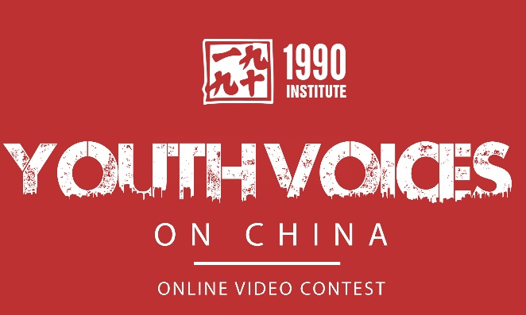

Youth Voices on China (YVOC) Video Contest

MIDDLE SCHOOL PROJECT

For this project, you will create a 2-3 minute video on the following topic:
What’s China? Why understanding China is important to my future

Guidelines
- Your video should be at least 2-3 minutes
- You can submit a video, rap, animation, or other presentation.
- Create a unique response to the YVOC theme above.
- Show ways to create bridges or dialogue with Chinese youth.
- Encourage your friends and peers to learn more about China.
- Tell a compelling story that lets your or your team’s voices be heard.
- Make your video or presentation creative, thoughtful and entertaining.

STEP ONE: Decide and Research (Two Days)
Decide on a topic, answer, or question you would like to raise on the theme.

Gather all the information--facts and opinions--you can on the issue. Be sure to keep track of your sources for a bibliography. Identify several positions you might cover on this issue.

Decide: Who or what could I show with the camera that will communicate your information to the audience?

STEP TWO: Script and Storyboard (Two Days)

DUE
Before you go into production, create a script outline with storyboards illustrating specific shots. It should include: locations to explore, people to be interviewed, events to capture, situations to show, documents or still photos to include, artwork, quotations, video clips you might include, etc.**
**Be sure any copyrighted material is used under "fair" use guidelines.

STEP THREE: Production (Five Days)
Gather the people, articles, and all equipment and supplies you will use in your video or other media presentation. Follow your storyboards and film or produce your draft product.

Keep in mind that your video or other presentation should:
- Give all necessary facts and background on any issues.
- Include music, photographs, drawings, and any other material important in telling your story.
- Be sure to include all your sources and credits.
- If you are going to videotape, be sure what you are videotaping is relevant.

Shooting video: There are some basic rules to follow when shooting your video footage. Consider lighting, framing, positioning, camera steadiness, speed of camera movement, sound, how many seconds you hold a shot, etc. A note about interviewing: think carefully about the questions and answers, the preparation, position, location and appearance of the interviewee. Careful planning can lead to better video footage for your final product.

Edit your production into a final draft.

STEP FOUR: Editing (Two Days)

DUE
Editing is a critical phase of creating your video. Think of the editing process as similar to the writing process, and your video footage as the words you will use to tell your story. Let the story "tell itself" through the video. In what order will you arrange the story? How will it end? What pieces work well together? What pieces should be left out? You may want to look at all of your content then write out an "editing script" to decide the scenes you will choose to show. You could also use storyboards to arrange your shots.

You may also realize you are missing some scenes and have to shoot more video. This is OK.

Write any narration or voice-over you may need from your editing script. Will you include music?

STEP FIVE: Feedback (2-3 Days)
Show your video to someone else. Is it clear? Are things included they DO NOT like or do not think will work? Are things included they DO like or think will work well and should be left in?

Identify all potential errors (spelling, names, scenes that change such as from light to dark when they should not, etc.).

STEP SIX: Finalize and Submit (by January 19, 2015)
Go through all the edits and feedback and develop a finished video (or presentation). Turn in to the instructor for approval and sign off (By January 12).

Work with your teacher and submit your video (or other presentation) to YVOC.
Submit to: http://youthvoices.1990institute.org

