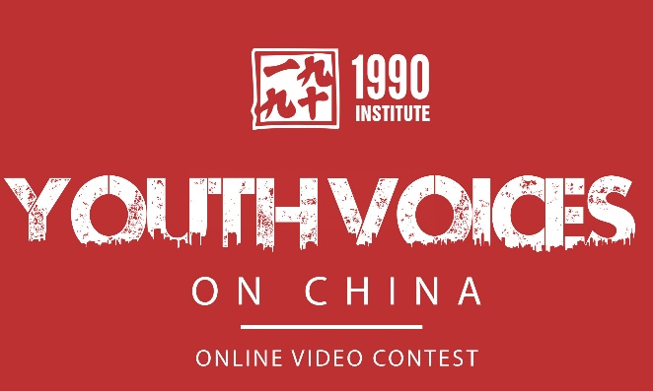

Youth Voices on China (YVOC) VIDEO CONTEST

HIGH SCHOOL PROJECT

Students submitting to the YVOC contest: You may do this on your own or with one or two other students. These projects will be worth 100 points and an additional 10 points in extra credit for the extra work involved. Your videos should be submitted to the YVOC website (http://youthvoices.1990institute.org ) by midnight on January 19, 2015. Please turn in a copy to me by Jan 12, 2015. Videos larger than 2GB will not upload to YVOC. Your film must be submitted to YVOC on time to get credit for the project.

This first year’s topic for the video contest is:
What’s China? Why understanding China is important to my future

I will check-in with you to find out that you have completed the following steps by the due dates indicated. Save this assignment sheet, so I can check off when each step is completed:
YVOC group and topic selected (November 7, 2014)
Topic solidified/research completed (November 20, 2014)
Any external talent (subjects to be in the video) confirmed (November 24, 2014)
Video (or other media) Storyboard/script completed (December 2, 2014)
All original filming/production/writing completed (December 12, 2014)
Completed video which meets all YVOC requirements turned in to me by Jan. 12, and successfully submitted to YVOC (January 19, 2015)

When you finish these steps, come to see me so I can check them off. You will also receive a grading rubric for the project, based on YVOC’s requirements.

Please write on a sheet of paper the people with whom you will work and your general topic, and turn it in to me by Friday, November 7, 2014.

Your YVOC project will be graded based on the guidelines and the following criteria for the contest from YVOC (youthvoices.1990institute.org). Students’ videos should:
- Create a unique response or answer to the YVOC theme.
- Share ways to create bridges and dialogue with Chinese youth.
- Encourage one’s American peers to learn more about China.
- Tell a compelling story that expresses students’ voices.

Judges have made the following comments regarding their assessments of the videos:
- Videos should be creative, thought-provoking, and entertaining.
- Videos may be funny, sad, serious, topical, documentary or fiction.
- Students can submit videos, raps, animations, or other presentations.
- Submissions may raise controversies, take stands, create dialogues, exchange ideas, or other.

YVOC Group Name

Names of Group Members & their Roles:

Ideas for general topic:

