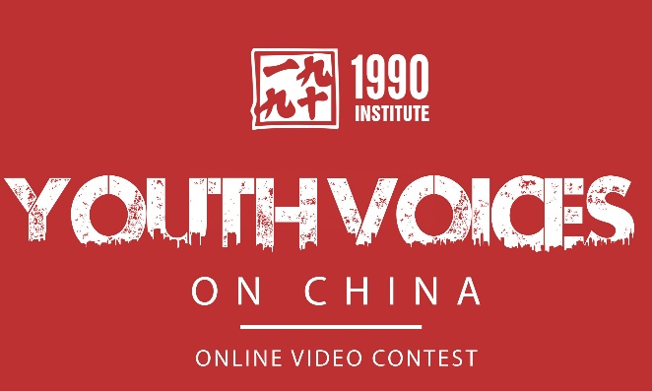
1990 Institute YVOC Video* Contest RUBRIC

Teacher Name:

Student Name:

CATEGORY | 4 | 3 | 2 | 1
Meets YVOC Theme | Presents a unique view, issue, or topic on the YVOC theme. Content knowledge is clearly shown. | Covers a unique view, issue or topic on the YVOC theme, but may lack interest/uniqueness. Knowledge shown is sufficient. | Presents a view, issue, or topic on the YVOC theme, but lacks interest. Knowledge is evident but may be incomplete. | Presentation covers the YVOC theme, but may be incompletely covered, lacks interest, and shows incomplete knowledge.
Tells a compelling story | Story told is compelling and complete. | Tells a good story but may be incomplete or not compelling. | Tells an appropriate story for the theme but is not sufficiently compelling. | Does not tell a story.
Meets Video & Technical Requirements | Video (presentation) is 2-3 minutes long, sufficiently covers the theme topic, and is under 3 GB. Video is submitted on time to YVOC. | Video (presentation) is 2-3 minutes long but lacks substance on the topic. It may be to large of a file. It is submitted on time to YVOC. | Video is not 2-3 minutes long, or is insufficient length to cover the topic. Video is submitted on time to YVOC. | More than one requirement was not completely met.
Creates bridges, dialogue, or learning about China | Presents a topic that stimulates thinking about Chinese-American cultural relations and understanding and encourages learning more. | Addresses Chinese-American cultural understandings and relations, but may not stimulate curiosity or interest. | Covers Chinese-American cultural relations but lacks interest and does not stimulate a desire to learn more. | Little or no coverage of Chinese-American cultural relations or understanding.
Information is accurate, honest and sources identified | Video (presentation) presents accurate information, speaks honestly on the topic and tells the source for all information used. | Most information presented is accurate and speaks to honest opinions or views; does not tell source of all information. | Details of the topic are unclear or not completely accurate. Does not offer the sources for any of the information presented. | Presentation is unclear or gives inaccurate information; no sources of information are covered.
Overall Presentation | The presentation shows knowledge of subject, creativity, smooth flow and a clear group effort. | The presentation shows elements of: subject knowledge, creativity, smooth flow and some group effort. | The presentation shows minimal elements of: subject knowledge, creativity, smooth flow and low group effort. | The presentation lacks most of the elements: subject knowledge, creativity, smooth flow, or group effort.
* Submissions may be in a Video, Rap, Animation, or other Presentation mode

