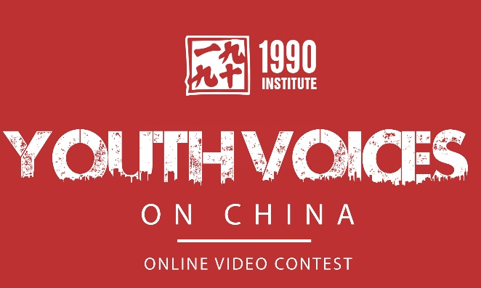

YVOC 2014 Student Video* Grading Rubric | High School Students
Student Name:
CATEGORY | 4 Expert/Professional | 3 Proficient | 2 Developing | 1 Novice
Responds to the YVOC Theme | Presents a comprehensive view of the chosen topic in-depth and aids understanding.  Knowledge of issue is well displayed in video. | Defines the chosen topic and Includes essential and sufficient knowledge and details. Subject knowledge appears to be good. | Includes essential information about the topic, but more information is needed. Topic may not be clearly identified. | Content is minimal OR there are factual errors.
Tells Compelling Story (creativity, originality) | Story demonstrating the topic is compelling. Video shows a large amount of original thought. Ideas are creative and inventive. | Story demonstrating the topic is appropriate for the topic; but may not be current or exciting for other students. Video shows some original thought, ideas and insights. | Video shows thought and attention to the theme, but there is little evidence of original thinking. Little or no use of personal or compelling stories. | Video does not tell a story for demonstration. There is no evidence of original thinking or attention to the theme.
Video (or presentation) Requirements | Video is 2-3 minutes long and is sufficient to cover the topic; video is under 3 GB. Video is submitted on time to YVOC. | Video is 2-3 minutes long and able to cover the topic. Video is submitted on time to YVOC. | Video is not 2-3 minutes long, or is insufficient length to cover the topic. Video is submitted on time to YVOC. | More than one requirement was not completely met.
Creates bridges and dialogue and encourages Learning about China | Coverage of the chosen topic stimulates deeper thinking about inter-cultural understandings and relations between American and Chinese youth; raises a desire to learn. | Coverage of the chosen topic addresses inter-cultural understanding between American and Chinese youth, and may raise curiosity to know more. | Video raises questions about intercultural understanding and relations between American and Chinese youth; but does not stimulate viewers to learn more. | Little to no attempt to cover issues of inter-cultural understanding or relations between Chinese and American youth.
Works Cited | Source information was collected and is displayed in some manner for all images or graphics, footage, facts and quotes. Sources are documented in chosen format. | Source information collected for all graphics, footage, facts and quotes and much of it is documented in the chosen format. | Source information was collected for images/graphics, footage, facts and quotes, but may not be displayed and is not documented in the chosen format format. | Very little or no source information was collected or displayed.
Students may do any of the presentation formats identified in the YVOC guidelines. The rubric applies to any method of presentation chosen.

